Dashboard Design Report
Team ID | MCA
Project Name | Digital Well-Being & Addiction Insights Dashboard
Maximum Marks | 5 Marks

Creating an effective dashboard involves thoughtful design to ensure that the presented information is clear, relevant, and easily understandable for the intended audience. Here are some key principles and best practices for dashboard design applied during this project structure:
Interactive and Visually Appealing Dashboards
Designing highly engaging and interactive user interfaces involves a deep combination of clear layout management, thematic coherence, and responsive control structures. The following focus criteria were leveraged to formulate the design environment:
- Dark and Uniform Canvas Theme: Utilizing a cohesive charcoal gray background canvas to give the colorful data metrics and charts high contrast and high clarity.
- Top-Level KPI Summaries: Placing the most critical metric indicator blocks directly at the top header panel so the user instantly captures target audience scales, screen durations, and rest standards.
- Segmented Behavioral Insights: Splitting complex multi-layered user details systematically into structured blocks including gender splits, active age groups, stress scales, and addiction categories.
- Interactive Dropdown Filters: Integrating an 'addiction level' filter module in the top right window quadrant, giving viewers interactive capabilities to slice through subsets of database points.
- Clean Visual Component Sizing: Structuring visual weights cleanly with evenly balanced horizontal column systems and centralized data distribution charts for immediate visual parity.
Major Data Outcomes from the Dashboard Analysis
- Total Monitored Audience: The analytical framework keeps track of an aggregate user pool totaling 7,500 user IDs to define basic structural scale parameters.

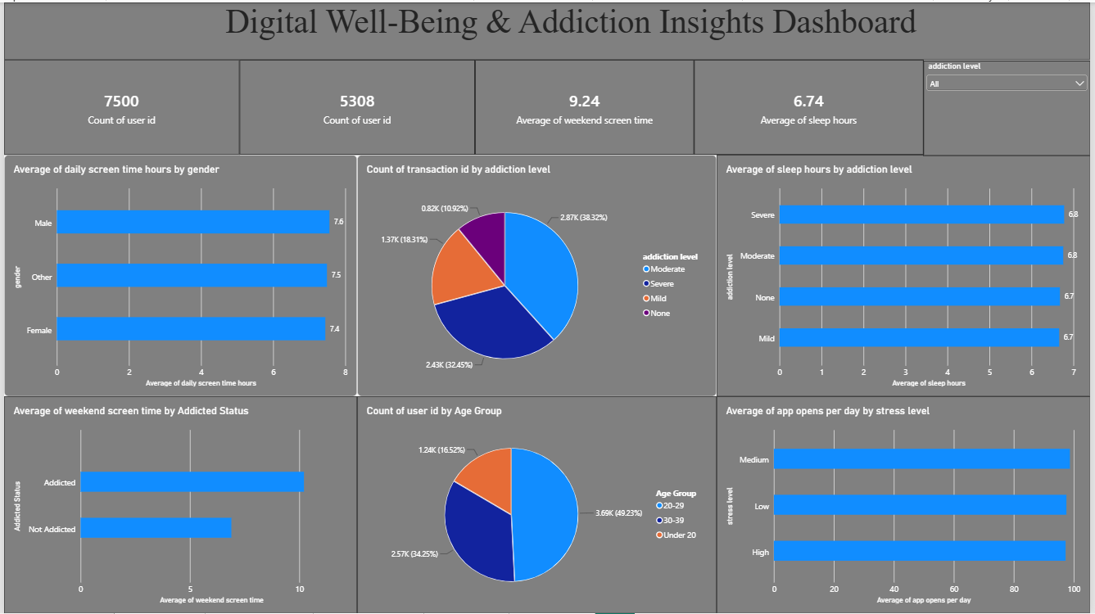

- Active Sample Data Tracking: A specific targeted dataset cluster containing 5,308 distinct user IDs is processed cleanly to accurately filter deeper psychological and daily habits.
- Weekend Screentime Elevation: The data maps a massive baseline average of 9.24 hours of weekend screen time, featuring an intense divergence where individuals tagged under 'Addicted' statuses register significantly higher device usage compared to those classified as 'Not Addicted'.
- Rest Sufficiency Benchmark: The metrics track a cross-group mean sleep length of 6.74 hours, maintaining stability across all core segments (Severe, Moderate, Mild, and None categories) within a narrow 6.7 to 6.8-hour threshold.
- Gender Behavioral Equity: Daily screen time allocations depict clean equity across physical gender dimensions, recording an average of 7.6 hours for Males, 7.5 hours for Other, and 7.4 hours for Females.
- Addiction Categorization Breakdown: Data profiles reveal that Moderate addiction stages represent the largest user concentration slot at 38.32%, immediately followed by Severe tiers at 32.45%, Mild levels at 18.31%, and None at 10.92%.
- Generational User Distribution: Young adults spanning the 20–29 age demographic encompass the primary audience share at 49.23%, whereas the 30–39 cluster handles 34.25%, and the youth segment Under 20 marks out the final 16.52%.
- App Interactions Under Stress: Daily interactions hold incredibly steady at roughly 100 app opens per day across all stress levels (High, Medium, and Low), confirming that psychological stress variations do not alter the physical automated habit loops of updating or browsing software applications.

